

**Image Classification**

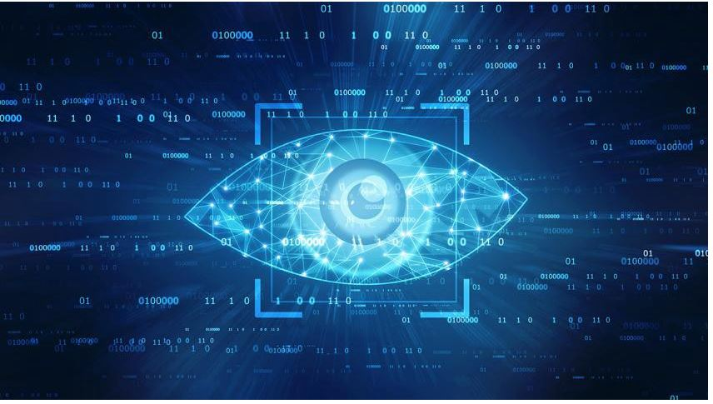

Submitted by

Krishna Prasad

**ACKNOWLEDGMENT**

Working on this project has an incredible experience that will have an impact on my career.

It is pleasant gratification to present Image Classification.

I have completed this project by taking the help from Google, Bing and You tube.

**INTRODUCTION**

In this Project I have done Web Scraping by using image classification of that is men’s jeans, men’s trousers and sarees.

##### After completing Web scrapping and converting all the scrap data into Dataset. From which I understand from this dataset I have to predict images.

##### Image classification (or Image recognition) is a subdomain of computer vision in which an algorithm looks at an image and assigns it a tag from a collection of predefined tags or categories that it has been trained on.

##### Vision is responsible for 80-85 percent of our perception of the world, and we, as human beings, trivially perform classification daily on whatever data we come across.

##### Image classification is the process of categorizing and labelling groups of pixels or vectors within an image based on specific rules. The categorization law can be devised using one or more spectral or textural characteristics. Two general methods of classification are 'supervised' and 'unsupervised'.

##### Image classification is a complex procedure which relies on different components. Here, some of the presented strategies, issues and additional prospects of image orders are addressed. The primary spotlight will be on cutting edge classification methods which are utilized for enhancing characterization precision.

**Importing Libraries**

*I am importing all the library which I required for EDA, visualization, prediction and finding all matrices. The reason of doing this is that it become easier to use all the import statement at one go and we do not require to import the statement again at each point***.**

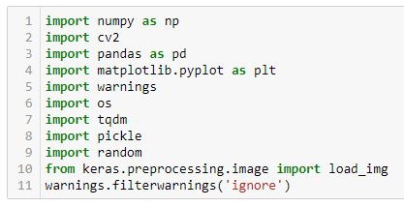

* Data Sources and their formats

Now I am going to upload or read the directory.



#### Loading the path from directory to read the images for a dataset.

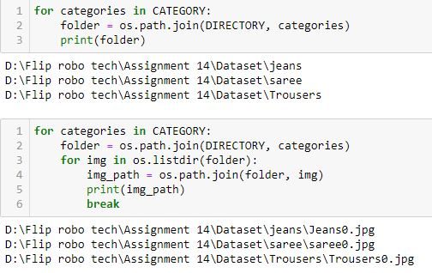

##### *Loading all the category into jpeg.extension.*

### Exploratory Data Analysis

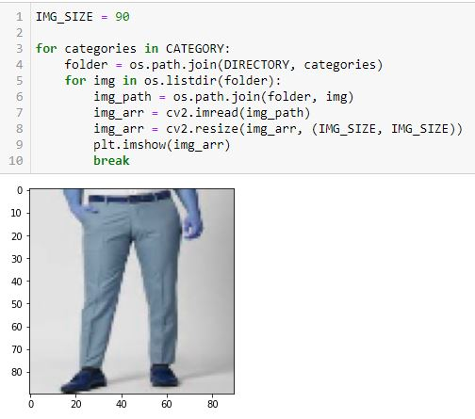

#### By using os converting all the images.

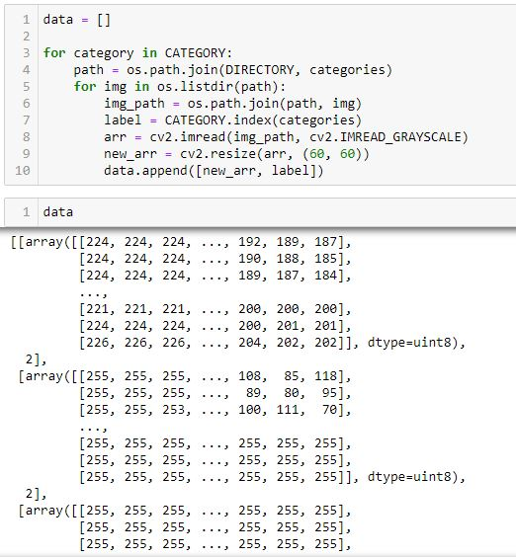

#### Converting all the dataset into array.



#### Checking the len values which shows 747 images included in this project.

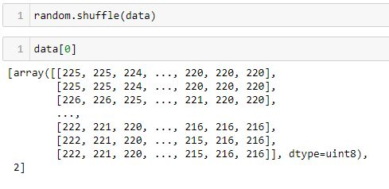

#### Shuffling all the data to make a proper dataset for model prediction.

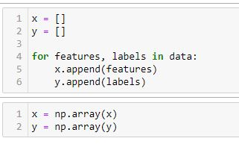

Appending features & label into a data.

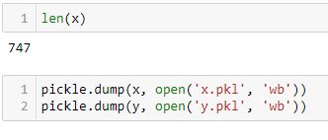

#### Saving files through using dump.pickle options.

## Training Model



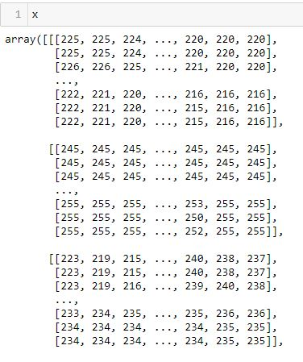

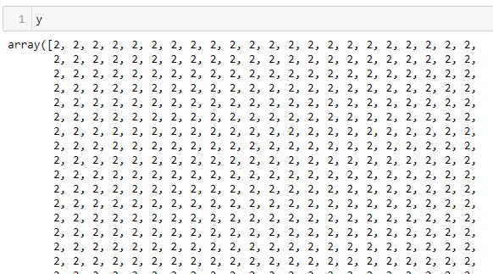

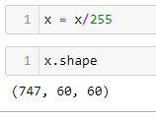

#### Using shape function to understand image size of a file.